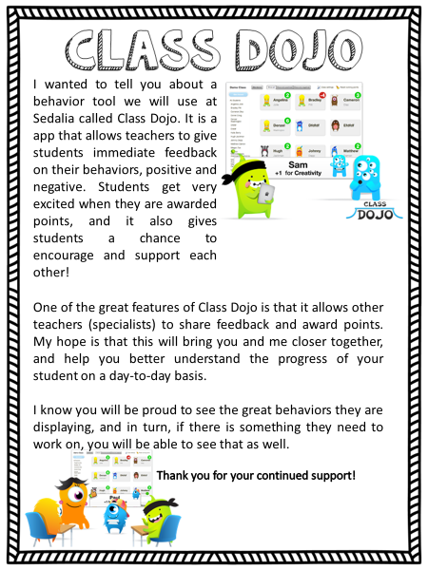

Classroom Rules will follow the school-wide PBIS(Positive Behavior Intervention School) goals for students to be Respectful, Responsible, and Safe.